BITS PILANI, DUBAI CAMPUS
DUBAI INTERNATIONAL ACADEMIC CITY, DUBAI

FIRST SEMESTER 2023 – 2024
COURSE: CSF301 (Principles of Programming Languages)
COMPONENT: Tutorial Sheet 5b DATE: 25 October 2023

I. DRAW the layout of the Activation Record (Stack frame) for the following segment of C code:
#include<stdio.h>
void myfun(int *a, int *b);
int main()
{
int m = 10, n = 20;
printf("\n m = %d \n n = %d",m, n);
myfun(&m, &n);
}

void myfun(int *a, int *b)
{
int tmp1, tmp2;
tmp1 = *a + *b;
tmp2 = *b - *a;
printf("\n tmp1 = %d \n tmp2 = %d \n", tmp1, tmp2);
}

II. Practice Problem:
DRAW the layout of the Activation Record (Stack frame) for the following segment of C code:
#include <stdio.h>
float square ( float x ) // function definition
{
float p ;
p = x * x ;
return p;
}
void main( )
{
float m = 25, n ;
// function call
n = square (m) ;
printf ("%f %f\n", m,n);
}

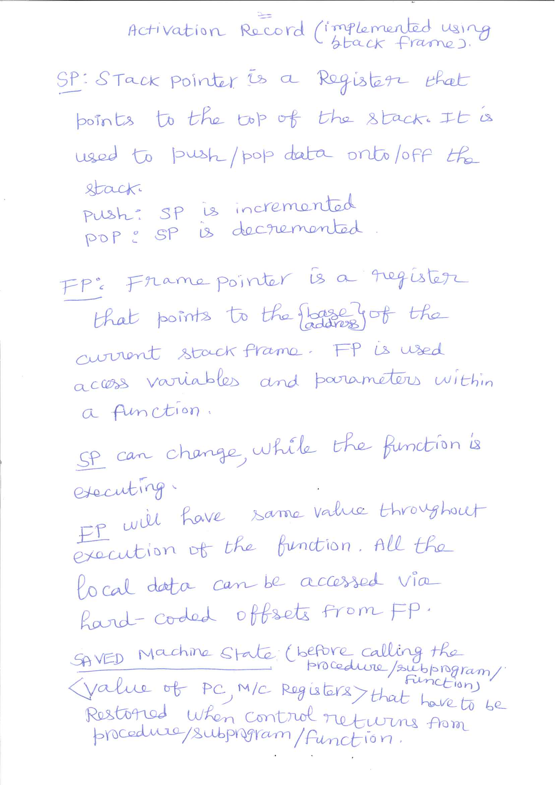

Suggested Answer: I

